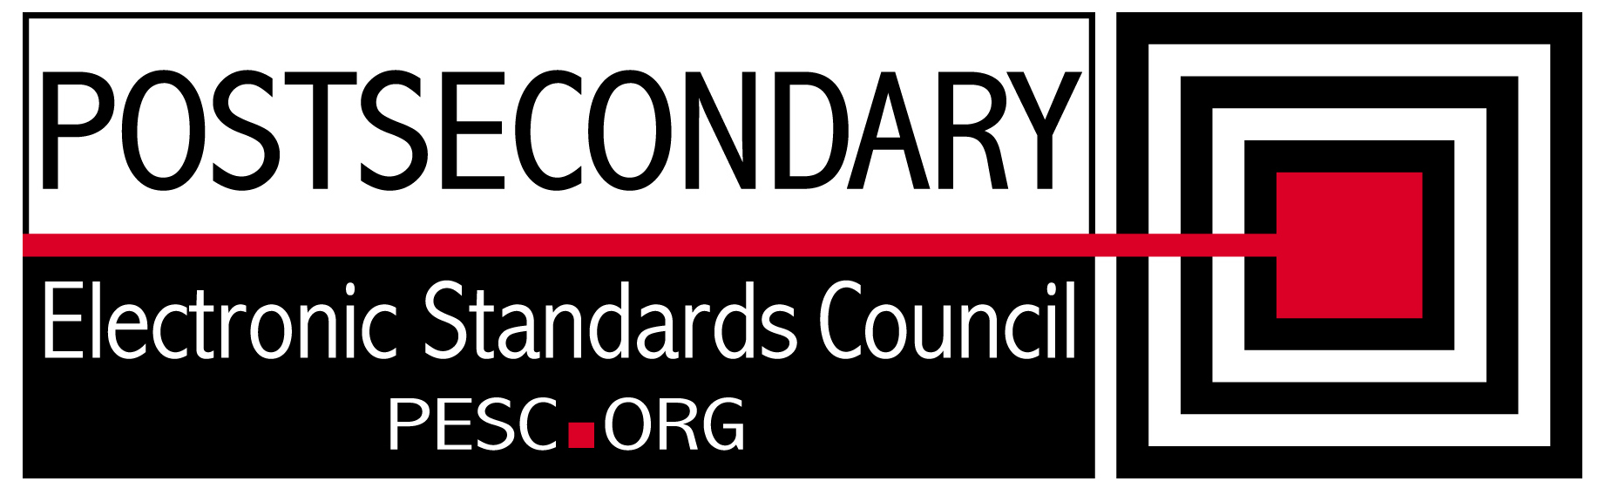

Standards Forum for Education
Status Update Form

Workgroup/Board Group Name | Technical Advisory Board
General Summary of Status | Identified changes in PESC Schema that need to be made for NIEM
Status Flag (Red/Yellow/Green) | Green
Report Data | 5/11/12
Projected Completion Date | Standing PESC Board

Item | Responsible Resource | Status  (Report update status of Deliverable/Objective  since last report)
Planned Deliverables/Objectives
(Provide at least 3)
Implementation Guide | Morris/TAB | The TAB is investigating various tools (OXygen, XML Spy, CAM, XML R&R) to determine best tool to automatically generate Implementation Guide.
NIEM Evaluation | TAB/David Webber | Identified key areas of change including xs:groups and component naming. David modified CAM tool to generate changes from CAM Template
XML R&R | Morris/Sue Lou (FSA) | Waiting for definitions and transform from CAM tool
Guideline for XML Architecture and Data Modeling revision | TAB | On hold until NIEM approach is settled.
Accomplishments/
Completions
NIEM Evaluation | David Webber | Presented progress at Spring Summit
Issues/Obstacles
NIEM structures requirement | David Webber | Adding meta data to PESC tags would produce incompatibilities with instance documents. Searching for a compromise.
Meetings/Calls Since Last Update | 4

Note: Chairs and/or leaders of workgroups, boards and committees under The Standards Forum for Education are required to provide updates during the Steering Committee’s monthly conference call meeting held the second Friday each month at 2:00pm EST. Call in information is: 866-352-3799 *7696363*. Forms must be completed and submitted prior to meeting time. Forms may also be posted on the PESC website as needed to provide the community at-large with a means to obtain updates for ongoing, but yet to-be-completed development efforts.

To add rows to table, click outside of the table, to the right on the row where you want to add another row . With cursor blinking, hit the enter key. A new row will be inserted.

